Greenfield Farms Homeowner’s Association
  - Fence Policy Guideline
PURPOSE
This policy aims to establish guidelines and/or processes as spelled out in the Declaration of Covenants, Conditions, Easements and Restrictions (CCER) of Greenfield Farms (GFF) to ensure compliance with the GFF CCER for the installation, maintenance, repair, and cleaning of yard and garden fences. This policy will greatly enhance the uniformity in “maintaining and enhancing the architectural characteristics” within the community. It will lend continuity in the approval process for the Architectural Review Board (ARB), enforcement process for the Board of Directors (BOD), and planning, selection, and maintenance for homeowners.
ELIGIBILITY
All homeowners within the community are eligible to install fences on their properties, subject to compliance with the guidelines outlined in this policy and the Homeowners Association (HOA) CCER. Compliance will be determined by members of the ARB (or BOD) and written approval must be obtained prior to installation.
Article IV, Introduction, and Article V, Sections 1, #13 of the CCER.
APPROVAL PROCESS
Any installation of yard and/or garden fences requires approval from the GFF Architectural Review Board, or if required by the Board of Directors. Compliance with this policy does not ensure 100% approval as this guideline may not account for every possible variation or type of installation. However, it should aid in the planning process and upon submission, greatly increase the rate of application approval.
Variation from approved applications will require an amended application and additional written ARB approval.
The application for approval will be processed and approved by the ARB in the same manner as an application for approval of an architectural modification to the property.
As specified in Article IV “Architectural Control” of the CCER of Greenfield Farms – all applications must include plans (e.g. materials, color, location layout, etc.) appropriate for the fence installation. Article V “General Restrictions” (#13) may further limit the project scope.
COMPLIANCE
Existing fence(s) within the HOA is not reason to assume your ARB fence application will receive approval.
To install or modify a fence (approved or existing) without a written ARB approval is prohibited. Any questions please contact the ARB and/or BOD whether an existing fence complies with current fencing policy.
Responsibility rests with the homeowner to ensure all fences comply with all local building codes, zoning regulations, and safety standards.
Strict compliance with the following sections of the CCER is required to maintain and enhance the existing architectural characteristics of the neighborhood.
Article IV, Introduction, and Article V, Sections 1, #13 of the CCER.
INSTALLATION REQUIREMENTS AND GUIDELINES
PLEASE REFERENCE FOOTNOTES, AS APPLICABLE
- All fences (yard and garden) require written ARB approval.
- The ARB and/or BOD reserves the right to be more restrictive in the approval process, as applicable, to ensure alignment with the GFF CCER.
- ADDENDUM A: Photograph Examples of most Approved Yard Fences (Not representative of all fences)
- ADDENDUM B: Photograph Examples of most Approved Garden Fences (Not representative of all fences)
- ADDENDUM C: Photograph Examples of most Disapproved Yard/Garden Fences (Not representative of all fences)
DESCRIPTION | YARD |  | GARDEN
RAIL MATERIALS (BETWEEN POSTS)
"Chain link & other bare wire fencing" (ref. CCER, Art. V, Sec. 1, Par. 13) |  | N |  | N
"Wire mesh inside split-rail fences" (ref. CCER, Art. V, Sec. 1, Par. 13) |  | Y |  | Y
Wrought iron / steel / aluminum |  | Y |  | Y
Plastic fence (i.e. panel, picket) |  | Y |  | Y
Timber / wood |  | Y |  | Y
Vinyl-coated wire (not to be confused with CCER “bare wire”) |  | N |  | Y
Plastic mesh – garden fence only |  | N |  | Y (Ref. #4 Footnote)
Pipe |  | N |  | N
Brick/Stone |  | N |  | N
Horizontal & vertical railing cable |  | N |  | N
Electric |  | N |  | N
Snow bridge fence (wood/plastic) |  | N |  | N
POST MATERIALS
Wrought iron/steel / aluminum |  | Y |  | Y
Plastic |  | Y |  | Y
Timber/wood |  | Y |  | Y
Granite |  | Y |  | Y
Brick/Stone |  | N |  | N
Rebar/concrete |  | N |  | N
COLORS
White |  | Y |  | Y
Black |  | Y |  | Y
Earth tones / neutral paints & stains |  | Y |  | Y
Neon, brights, blue, purple, red, orange, yellow, etc. |  | N |  | N
LOCATION / HEIGHT (not to exceed height)
Front Yard |  | 4 ft Max |  | N
Side & Backyard |  | 6 ft Max |  | 4 ft Max
MAINTENANCE & REPAIRS
Homeowners are responsible for the regular and periodic maintenance, painting, upkeep and/or cleaning of their fences. Repairs and/or replacements should be done promptly and in accordance with manufacturer guidelines (if applicable) to avoid unforeseen conditions and safety issues that may pose a risk of damage to people and neighboring properties.

REMOVAL (PERMANENT OR SEASONAL)
The homeowner is responsible for restoring the property to its original condition at their own expense.

VIOLATIONS & NON-COMPLIANCE
Any violation and/or non-compliance shall and will be strictly enforced through the BOD, in accordance with the CCER.

BOD DISCLAIMER
This policy, any specific directive(s), and the approval/disapproval process as outlined above can be waived, revoked, and/or amended by GFF BOD majority vote. The BOD, with a majority vote, can tailor adherence and/or language to this policy, to the extent that it does not conflict with the language or intent of the GFF CCER. It is the responsibility of the BOD to set a course for neighborhood uniformity and consistency in “maintaining and enhancing the architectural characteristics” of GFF.

APPROVAL
GFF BOD Approved on November 12 2024.

ADDENDUM A: Examples of most approved Yard Fences (Not representative of all fences)
Natural tone wood panel fence
Earth-color brown panel wood fence

Natural wood picket fence
Black metal fence
Black plastic picket fence
White aluminum fence
White plastic picket fence
Pressure treated pine stockade fence
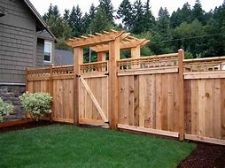
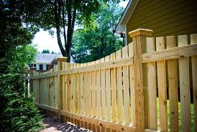
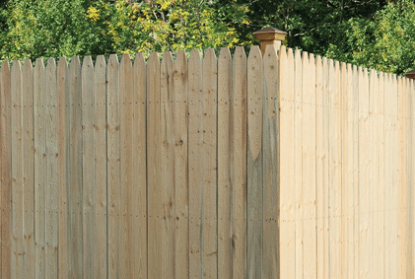
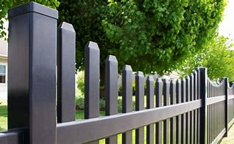
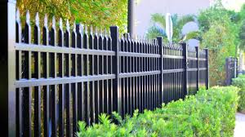
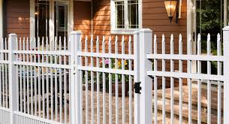
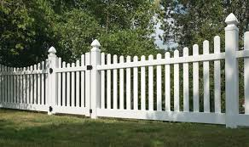
ADDENDUM A (continued): Examples of most approved Yard Fences (Not representative of all fences)
Black aluminum panel fence
White plastic panel fence
White plastic split-rail fence
White wood split-rail fence with granite posts
Black wood split-rail / wire mesh inside fence
White plastic split-rail / wire mesh inside fence
Natural wood split-rail / wire mesh inside fence
Black aluminum / wire mesh inside fence
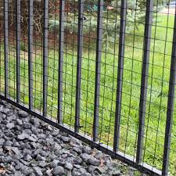
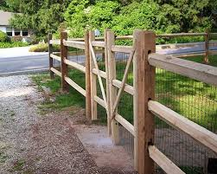
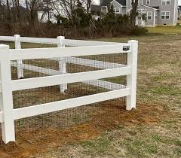
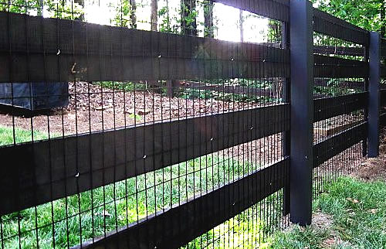
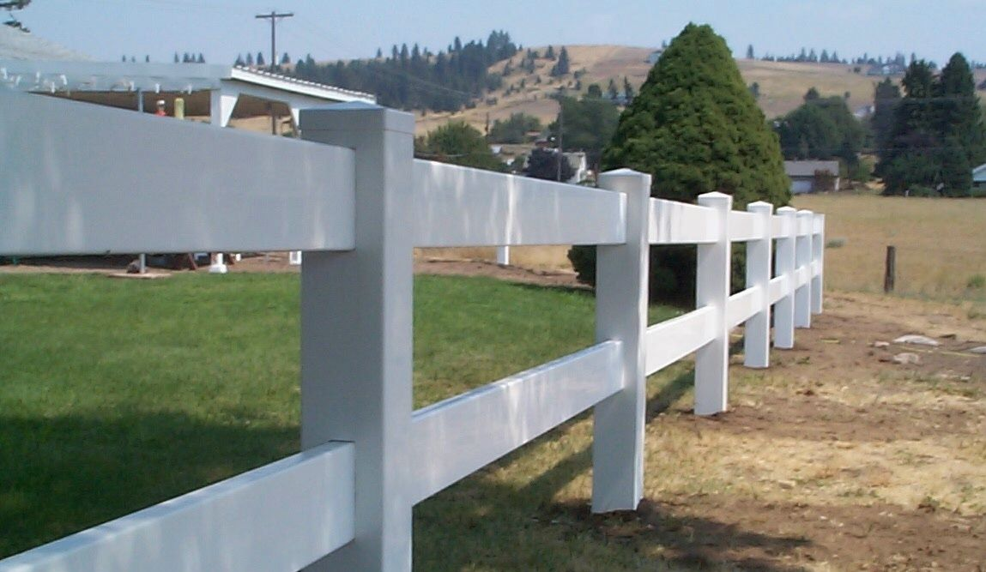
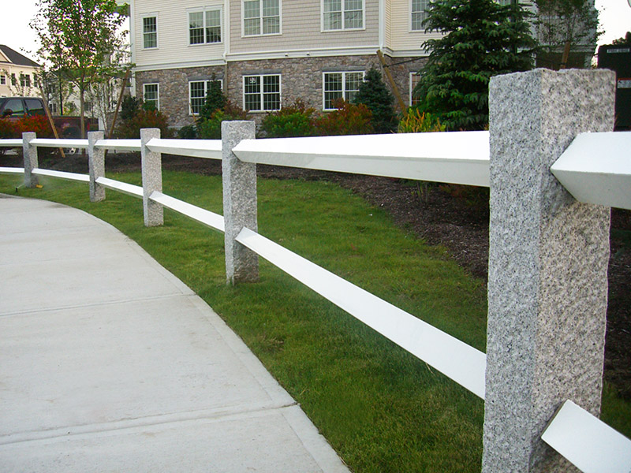
ADDENDUM B: Examples of most approved Garden Fences (Not representative of all fences)
Black aluminum vinyl-coated fence
Black steel vinyl-coated fence
White wrought iron fence
Green steel vinyl-coated wire fence
Black aluminum fence
Black steel fence
White steel fence
Green plastic garden fence
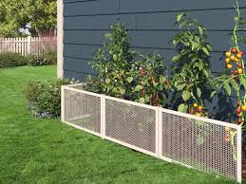
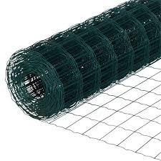
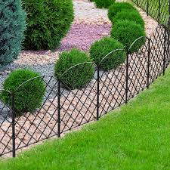
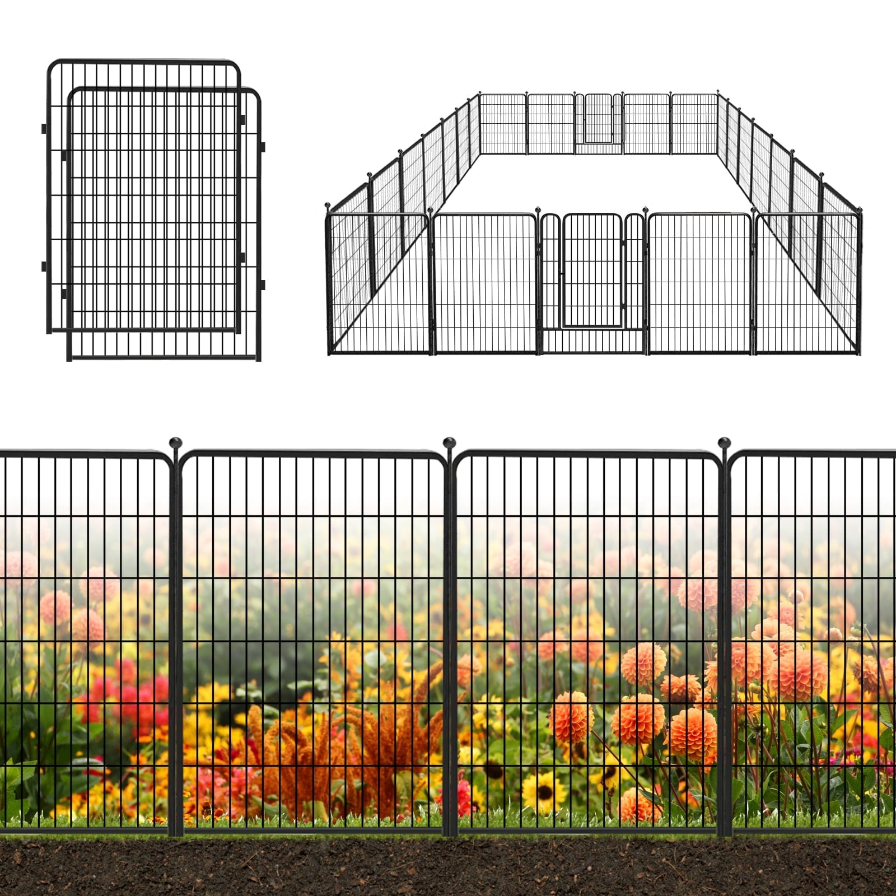
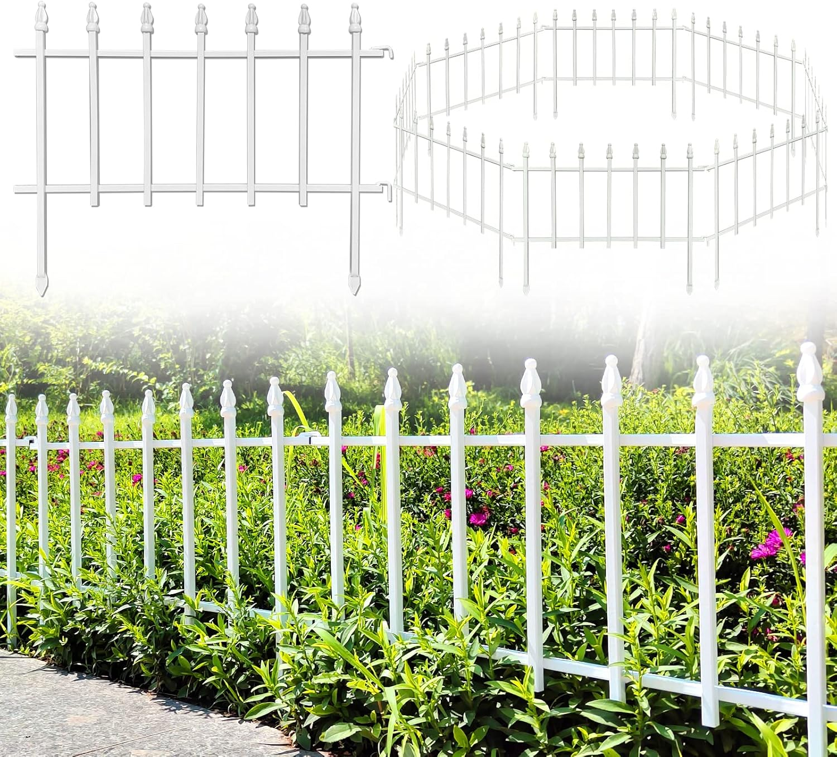
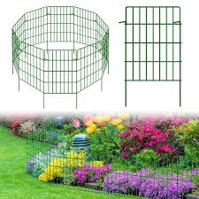
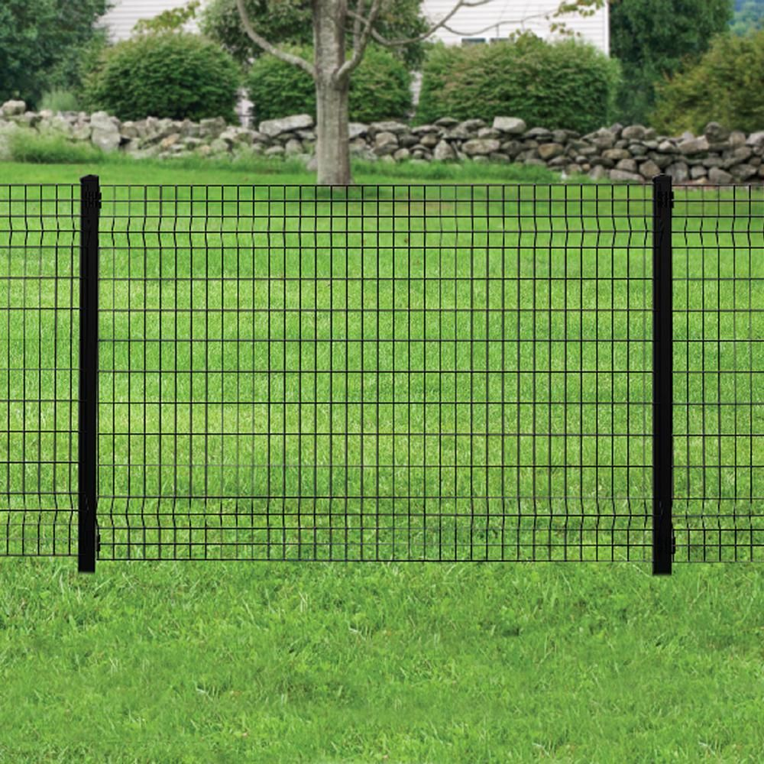
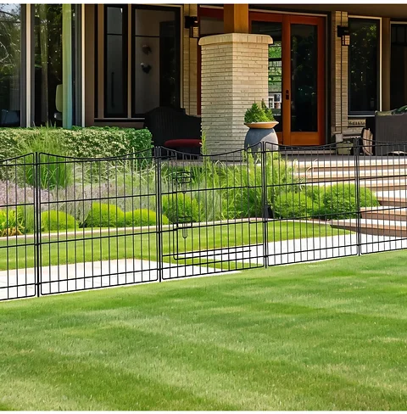
ADDENDUM C: Examples of most disapproved Yard and Garden Fences (Not representative of all fences)
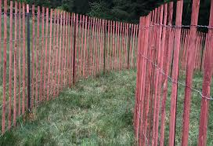

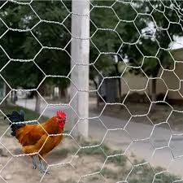
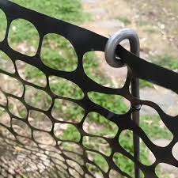
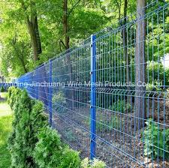
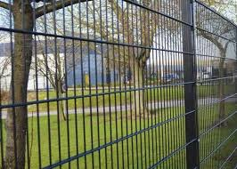
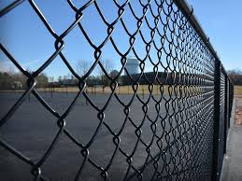
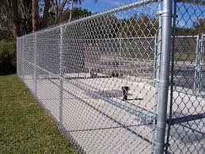

Black vinyl-coated chain-link fence
Chain-link fence
Blue bare-wire fence
Black vinyl-coated fence
Black plastic mesh fence
Orange plastic mesh fence
Red wood snow safety fence
Bare-wire chicken coop fence
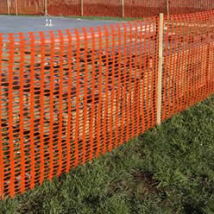
ADDENDUM C: Examples of most disapproved Yard and Garden Fences (Not representative of all fences)
Black metal pipe fence
Silver stainless steel cable railing fence
Red Brick fence
Black metal fence with brick posts
Yellow fence
Purple fence
Electric fence
Barbed wire fence
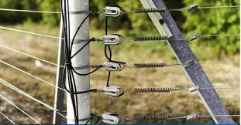

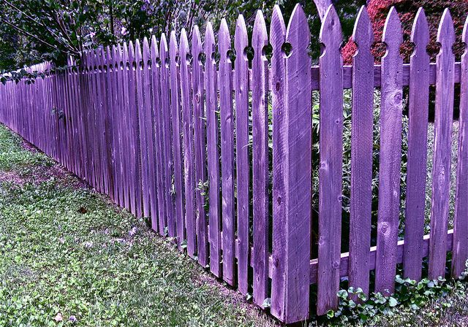
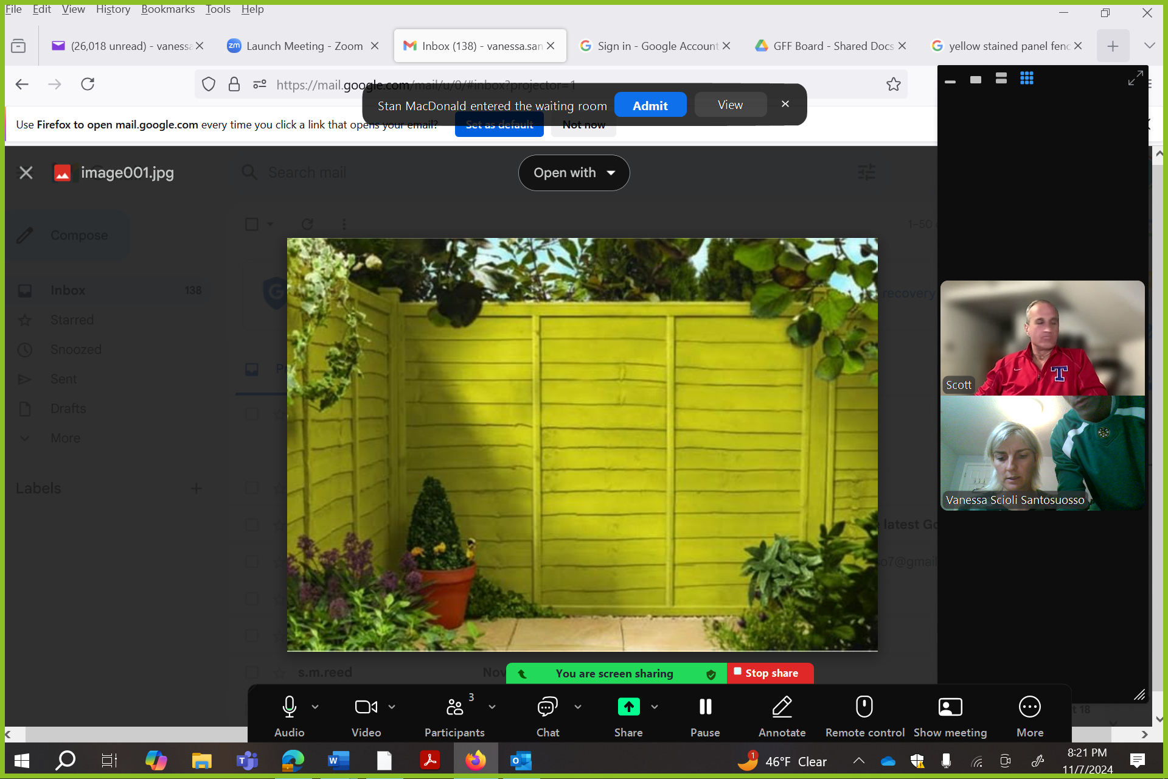
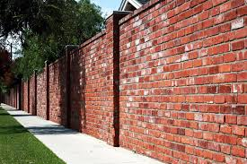
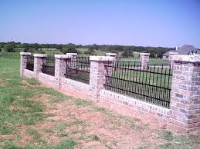
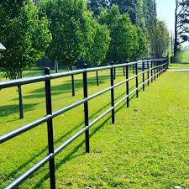
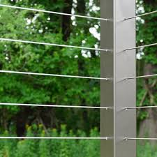

Temporary in nature. - Erected from 30 May through 30 September. Removed the remainder of the calendar year. - Enclosed area may not exceed 150 square feet to limit linear footage of fence. - Plastic mesh fence must be green and as least visible as possible. - Must be taut (not loose, falling over, and/or uneven).
To include barbed, single strand, galvanized, chicken coop, etc. is not approved.
To offer more choices and expand CCER regarding the “split-rail fence” definition, “wire mesh” situated behind a wood, plastic, or wrought iron fence (horizontal and/or vertical panels) will be considered.
Green plastic mesh is the only material color that will be approved (no black or orange).
This does not prohibit underground electric fencing for pets.
Post colors/materials should match rail and panel colors/materials to the maximum extent possible.
Defined as the portion of the land between the street & front of the house – no higher as to obstruct the view of the house & yard from the street.

